THE IMPORTANCE OF HUMAN RESOURCES METRICS IN RECRUITMENT PROCESS: CASE OF CHILDFUND ETHIOPIA

SARA NEGUSSIE FIRDAWOKE

Supervised by
DR. ELIAS BERHANU



Master of Arts in Public Administration
INDRA GANDHI NATIONAL OPEN UNIVERSITY
November 2017

DECLARATION

I hereby declared that the dissertation entitled THE IMPORTANCE OF HUMAN RESOURCES METRICS ON RECRUITMENT PROCESS: CASE OF CHILDFUND ETHIOPIA submitted by me for the partial fulfillment of the MPA to Indira Gandhi National Open University, (IGNOU) New Delhi is my own original work and has not been submitted earlier, either to IGNOU or to any other institution for the fulfillment of the requirement for any other program of study. I also declare that no chapter of this manuscript in whole or in part is lifted and incorporated in this report from any earlier work done by me or others.

Place: Addis Ababa, Ethiopia Signature: _________________________

Date: ___________________ Enrolment No.: ID1219209
Name: Sara Negussie Firdawoke
Address:
Bole Sub City, Woreda 4, H.No. 060
Tel. No. 251-911 13 38 22
E-mail: saranegu@yahoo.com

CERTIFICATE

Certified that the Dissertation entitled The Importance of Human Resources Metrics in Recruitment Process: Case of ChildFund Ethiopia submitted by Sara Negussie is her own work and has been done under my supervision. It is recommended that this Dissertation be placed before the examiner for evaluation.

(Signature of the Academic Supervisor)
Name: ________________________
Address: _______________________
_______________________
_______________________

Regional Center __________________
Study Center ____________________
Study Center Code: ______________

ACKNOWLEDGEMENTS

First of all, I want to thank the almighty God for every move that I passed through to do this task. Second I would like to express my sincere gratitude to my advisor Dr. Elias Berhanu for support and guidance on the study he has provided throughout writing this thesis. Beside my advisor, I would like to thank employee of ChildFund Ethiopia at country office and project offices for their help in gathering the right information including valuable comments and suggestions. I would also thank my friend Messeret Assefa and Haimanot Yemane, in gathering additional information that was helpful for my thesis and formatting the paper. Last but not least, I would like to thank my husband and my family for their continuous support and encouragement and patience.

Table of Contents

CHAPTER ONE 1
INTRODUCTION 1
1.1 Background of the Study 1
1.2 Background of the organization 1
1.3. Statement of the Research Problem 3
1.4 Research Questions 3
1.5. Objectives of the Study 4
1.5.1 General Objectives of the study 4
1.5.2 Specific Objectives of the Study 4
1.6. Significance of the Study 4
1.7. Scope of the Study 5
1.8. Limitation of the Study. 5
1.9. Organization of the Study 5
CHAPTER TWO 6
REVIEW OF RELATED LITERATURE 6
2.1 Human Resource (HR) Metrics 6
2.2 Recruitment and Selection - Getting the right people for the job 7
2.3 Quality of Hire (QoH) 10
2.4 Time to Fill 11
2.5 Costs per Hire (CpH) 11
2.6 Promotion 12
2.7 Turnover 12
CHAPTER THREE 14
RESEARCH METHODOLOGY 14
3.1 Research design 14
3.2 Population of the Study 14
3.3 Sample population 14
3.4 Data Source 14
3.5 Data gathering tools 15
3.6 Data analysis 15
CHAPTER FOUR 16
DATA ANALYSIS AND INTERPRETATION 16
4.1 General Characteristics of the Analysis 16
4.2 Demographic Characteristics of Respondents 17
4.2.1 Pre Hire Survey 17
4.2.2 Post Hire Survey 18
4.3 Current Practice of Recruitment and Selection at ChildFund Ethiopia 19
4.4 Types of candidate selection methods 21
4.5 Time to Hire 22
4.6 Average Time to fill for candidates passed through written and interview selection process 23
4.7 Detail Average Time to Fill 24
4.8 Average Time to Fill -Interview Only 25
4.9 Detail Average Time to Fill 26
4.10 Time to fill by position 26
4.11 Costs per Hire (CpH) 31
4.12 Average Recruitment Cost of Positions 33
4.13 Recruitment cost at country office 33
4.14 Recruitment costs at project office 34
4.15 Comparison of internal recruitment costs with cost of 35
agency recruitment 35
4.16. Promotion Speed of new hires 36
4.17 Turnover 38
4.18 Quality of Hire (QoH)- Effectiveness Metrics 41
4.18.1 Manager satisfaction on new hire performance 41
4.18.3 Pre-hire Analysis 43
CHAPTER FIVE 48
SUMMARY OF FINDINGS, CONCLUSIONS AND RECOMMENDATIONS 48
5.1 Summary of Findings 48
5.2 Conclusion 49
5.3 Recommendation 49
Bibliography………………………..………..…………...…………………………………50
Work Plan …………….…….…………………………………………………….………...53
Appendix A …………..…………………………………………………………………..…54
Appendix B …………………..…………………………………………………………..…59

 | List of Tables
 |  |  | Pages
4.1. | Rate of return of questionnaires distributed |  | 16
4.1.1. | Pre hire survey |  | 16
4.1.2. | Post hire survey |  | 17
4.2. | Demographic characteristics of respondents |  | 17
4.4. | Types of candidates' selection methods |  | 21
4.5. | The average time to fill (written & interview) |  | 22
4.7. | Detail average time to fill analysis (written & interview) |  | 24
4.9. | Detail average time to fill analysis (interview only) |  | 26
4.11. | Recruitment cost |  | 32
4.12. | Average recruitment cost of positions at country office |  | 33
4.14. | Average recruitment cost of positions at project office |  | 34
4.15. | Comparison of internal recruitment cost and cost of |  | 35
 | agency recruitment
4.16.1. | Promotion speed of new hire for FY 2015/2016 |  | 37
4.16.2. | Promotion speed of new hire for FY 2016/2017 |  | 37
4.17.1. | Reason for leaving ChildFund Ethiopia |  | 38
4.17.2. | Turnover analysis for staff served less than a year |  | 39
4.17.3. | Turnover analysis for staff served less than 6 months |  | 4ዐ
4.18.1. | List of Line Managers |  | 41
4.18.2. | Respondents' view on post hire survey |  | 42
4.18.3. | Respondents' view on pre hire survey |  | 44
4.18.4. | Respondents' view on ChildFund a place to work |  | 46
4.18.5. | Respondents' view on induction for new entrants |  | 47
4.18.6. | Respondents' view on means of recruitments |  | 47

 | List of Figures
 |  |  | Page
Figure 4.6 | Average times to fill (written & interview) |  | 23
Figure 4.8 | Average times to fill (interview only) |  | 25
Figure 4.10 | Average times to fill- Director Positions |  | 27
Figure 4.11 | Average times to fill- Manager Positions |  | 27
Figure 4.12 | Average Times to fill - Specialist Positions |  | 28
Figure 4.13 | Average times to fill -Officer Position |  | 28
Figure 4.14 | Average times to fill- Area Office Officer Positions |  | 29
Figure 4.15 | Average times to fill - Department Assistant Positions |  | 29
Figure 4.16 | Average times to fill - Driver Position |  | 30
Figure 4.17 | Average times to fill-Emergency Projects Position |  | 31

Acronyms
HR Human Resources
CpH Cost per Hire
QoH Quality of Hire
KPI Key Performance Indicator
HRAD Human Resources and Administration Department
JD Job Description
SHRM Society for Human Resources Management
TSFP Targeted Supplementary Food Program
WASH Water Sanitation and Hygiene
CMAM Community Based Management of Acute Malnutrition

Abstract
The aim of the study was to examine the impact of Human Resource (HR) Metrics towards human resource performance measurements specifically recruitment at ChildFund Ethiopia. HR metrics quantifies the HR activities in numbers and evaluates the HR function like recruitments and help align with the other departments’ objective. The study explores the existing recruitment system at ChildFund Ethiopia to identify gaps. The study focused on the time to fill, cost per hire, promotion speed of new entrants and turnover analysis for the FY 2015/16 to 2016/17. It also explores quality of hire. Here two instruments were used to gather data namely questionnaires and document analysis. The questionnaires distributed were two types; one for all employees and the other was for managers only. A total population of respondents participated in the study. The secondary data (documents) were purposely selected i.e. FY July 2015 upto June 2017. The data gathered using a qualitative method was analyzed. The selected documents for the study were also thoroughly analyzed. The study established that HR metrics has the potential to contribute significantly to the improvement of recruitment and other relevant HR performance at ChildFund Ethiopia. As the main finding of the study revealed there is a mismatch of HR staff vs total employee and number of recruits and high turnover. The study also reveals the strengths and weakness of recruitment at ChildFund Ethiopia. A significant strategy identified in this study recommends the need to match HR activities with HR staff for good quality of hire and acquit employees with better salary and benefit to minimize turnover.

Key Terms: HR Metrics, Time to Fill, Cost per Hire, Quality of Hire, Promotion Speed for new hires and Turnover

CHAPTER ONE

INTRODUCTION

1.1 Background of the Study
In any organization regardless of its type, there is a key resource without which it cannot be achieved its objectives. It is the human capital. Talent acquisition is one of the most urgent issues for any organization and the pressure to hire the right people has created an intensely competitive recruiting environment. The talent acquisition departments are expected therefore to take on a more analytical approach to hiring by tracking key recruitment metrics.

In this case it will be important for an organization to apply Human Resources (HR) Metrics to demonstrate to what extent HR activities meet defined priorities needs for the organization and support the overall organizational objectives. This allows the organization’s leadership team to develop and align the HR strategy to the strategies of other departments, and to integrate the HR strategy within the personal objectives of the HR team.

This paper has focused on examining the current practice of recruitment process at ChildFund Ethiopia and its assessment. It has also indicated solution for the problem and recommends possible strategies to improve the situation.

1.2 Background of the organization

ChildFund Ethiopia is an International non-governmental organization dedicated to serve deprived, excluded and vulnerable children and their families with appropriate and need based services. To improve the wellbeing of children and their families, the organization is implementing various projects and programs through its sponsorship and grant funding mechanisms. ChildFund Ethiopia works to assist and protect children in emergency situations and disasters. . Currently ChildFund Ethiopia has a total employee of 101. For the last two years ChildFund Ethiopia recruited 172 staffs out of which about 147 were emergency staff. The purpose of the recruitment is to bring positive change in communities in partnership with local organizations through three core programs that improve education, health and livelihoods and achieve the outcomes of healthy and secure infants, educated and confident children and skilled and involved youth. Considering the objective of the organization, reviewing the recruitment of ChildFund Ethiopia is becomes important. The followings are the Vision, Mission, Values and Operating Principles of ChildFund Ethiopia.

Vision
A world in which children realize their rights and achieve their potential.
Mission
HELP deprived, excluded and vulnerable children have the capacity to improve their lives and the opportunity to become young adults, parents and leaders who bring lasting and positive change in their communities.
Values
- Promoting positive outcomes for children
- Demonstrating integrity, openness and honesty, including stewardship of all resources
- Upholding the respect and value of an individual
- Championing diversity of thought and experience
- Fostering innovation and challenge
- Proactively connecting and collaborating

SERVE Operating Principles
ChildFund International’s SERVE Principles drive our overall approach to leadership and provides a framework for how the organization’s values are upheld in the day-to-day decisions we make. Operating principles of ChildFund
Strategy drives business decisions and relationships
Excellence is fostered through our deep commitment to accountability
Risks are assessed and incorporated in decision-making
Value from decisions, relationships and actions is added to our work with children
Every one of us is ChildFund

1.3. Statement of the Research Problem
Human Resource (HR) Metrics is a measurement of human resources data into meaningful information about the human capital. So, it helps us to track and measure performance of HR functions like recruitment & selection, performance, turnover, etc.

Colin Beames (2014) in his book entitled Advanced Workforce strategy mentioned that human capital is one of the least measured and analyzed investments, despite the fact that the highest percentage of the company costs are labor related. Thus, HR metrics should be practiced by organizations so as to assess the performance of HR functions which finally leads an organization towards success.

So the purpose of this work was to assess the recruitment process of ChildFund Ethiopia as a major HR function. Even though, efficient and effective recruitment process is one of the major HR functions which leads organization towards success, ChildFund Ethiopia couldn’t recognize it which finally results in HR staff dissatisfaction due to mismatch of HR staff vs total number of employees.

In order to find out solution, the researcher has planned to quantify the recruitment process activities in terms of number or percentage. It showed the worth/ value of HR function because it was expressed in terms of number/percentage.

1.4 Research Questions
The main purpose of this study is to examine the importance of Human Resource Metrics to develop and align the HR strategy to the strategies of other department and to achieve the organizational goal.
- Is there any practice in measuring efficiency and effectiveness of HR activities like recruitment, etc.?
- Does the organization know about Human Resource Metrics and its impact?
- Does the organization knows how much cost incurred for recruitment?
- Does the organization set minimum time to recruit a candidate?

1.5. Objectives of the Study

1.5.1 General Objectives of the study
The main objective of the research was to assess and analyze the practice of recruitment process and Quality of Hire of ChildFund Ethiopia and recommend possible solution.

1.5.2 Specific Objectives of the Study
To understand the recruitment policy and procedures of ChildFund Ethiopia
- To show major problems related to the recruitment procedures of Child Fund Ethiopia
- To identify the duration to recruit a candidate – time to fill
- To identify the cost incur to recruit a candidate – cost of hire
- To identify quality of hire through pre and post evaluation of new recruits, promotion speed of new entrants and turnover

1.6. Significance of the Study
One of the most important activities to bring the organization survival and success is effective and efficient recruitment process. In order to carry out quality of hire through modern HR techniques and system, adequate, qualified and engaged HR professionals are highly required. So any organization should acquaint with the appropriate HR professionals as it has huge impact for the success/failure of an organization. For example, due to inadequate and inefficient HR professional there might have a selection of wrong person and also have a chance of losing a right person. Both are equally costly to the organization.

This study has great importance and impact on ChildFund Ethiopia to view how recruitment process had an impact to achieve its core objective. It also initiates future research studies on this particular topic. This study also brings attitudinal change of higher level managers and employees towards the responsibilities of HR department and its professionals. This study showed some ideas as to how to quantify recruitment process activities.

1.7. Scope of the Study
This study focused on how the recruitment process in ChildFund Ethiopia has been practiced and assessed. The concept that has been analyzed by the study were recruitment and selection policy and practice, the duration and total costs to recruit a candidate, turnover analysis, employee and line manager level of satisfactions in recruitment. The study conducted at ChildFund Ethiopia taking a sample of recruitments made during the fiscal period July 2015 up to June 2017.

1.8. Limitation of the Study.
The study covers the most relevant HR metrics. The study also limited to assess the work done from the period July 2015 upto June 2017. Absence of appropriate documentation and shortage of time are factors to be mentioned. So the study depends on the secondary data since July 2015 and primary data like questionnaire and observation.

1.9. Organization of the Study
The paper organized into five chapters. The first chapter is the introduction which death with background, statement of the problem, objectives, significance, scope of the study.

The second chapter is the review of related literature which mainly describes the theoretical and empirical framework of the issues of HR metrics and practices. It deals with concepts, principles, and objectives of the subject matter of the study based on different books. The third chapter is the research design and methodology of the study. The fourth and the main chapter of this paper is the analysis and interpretation of the data collection. In the fifth chapter, summary of findings and conclusions has been drawn based on the analysis and possible recommendations have been forwarded based on the findings. The last part of the paper consisted of bibliography and other relevant appendixes.

CHAPTER TWO

REVIEW OF RELATED LITERATURE

2.1 Human Resource (HR) Metrics
Before choosing any study topic, it is advisable to review what has been done on the area. Accordingly , some books from Saint Mary library, internets and journals on HR Metrics/measurements of HR functions such as quality of hire, recruitment & selection, time to fill, cost of hire, turnover rate etc. have been reviewed

The followings are the brief description of the books/journals written on the HR Metrics and recruitment process in general and the main findings of the authors.

Erik (2016), defined HR metrics as indicators that enable HR to track and measure performance and also identifies different types of HR metrics like an average time per hire, early turnover, time till promotion, , cost per HR per employee, ratio of HR professionals to employees, revenues per employee, engagement rating and turn over.
The ideas of Erik stated above and my project work directly related in evaluating one of the HR functions- recruitment process. Among the HR metrics stated above , time to hire, cost per hire, turnover, and time till promotion have been proposed to assess the effectiveness/ efficiency of recruitment at ChildFund Ethiopia
Kandula (2004) on the other hand states that something, which is not measurable, is not manageable has picked up momentum in all business organizations. This has spread to all functions including HR. Kandula (2004) provided that may help the company to design HR measurements system. These are a) determine the objective of measurements,
b) Classify HR activities in terms of tangible and intangible c) develop measurements for tangible and intangible HR activities. Finally he has found out that measurement of HR activities is a potential opportunity for HR managers to prove the worth of HR in a language that is understood by all.

Similar with the work of Kandula, this paper identified most relevant HR measurements especially for efficient and effective recruitment process as follows.
- Determine the objective of measurement. It is to assess the financial (cost) and the non-financial (satisfaction of employee/ hiring manager) on quality of recruitment process.
- Classified the activities and develop measures for tangible (cost of hire, time to fill, turnover rate, etc.) and intangible (employee and line manager satisfaction on the recruitment process and candidate recruited).

- Classified the activities in terms of tangible (cost of hire, time to fill, turnover rate, yield ratio, etc.) and intangible (employee and line manager satisfaction on the recruitment process and candidate recruited).

2.2 Recruitment and Selection - Getting the right people for the job
According to Nick Boulter, Murray Dalziel, Jackie Hill (2005), recruitment and selection are enormously costly and time consuming for most organizations- and the higher the rate of turnover in a company, the greater the costs. So it becomes important to focus on how to improve the effectiveness of the recruitment and selection process and improve the quality of the candidates selected and measure the impact of good selection versus bad ones. It is found out that focused interviewing is proposed to apply for any kind of competency; it is simply a matter of designing a set of questions to structure the interview with relevant events. Trained interviewers can conduct a fair and efficient process, through which they can reliably assess specific competencies of the interviewee.

This concept really matches with the study like the quality of hire i.e. the selection system to acquire the right candidate through good recruitment and selection process. Here the HR metrics such as turnover rate, cost per hire, time to fill helped to assess recruitment process.

Based on Jane Weightman (2003) an appropriate recruitment system needs to be set up in every organization so that for each new recruits a routine exists which can be monitored. The system needs to be effective in producing enough suitable candidates, cost-effective and fair. It is suggested that good job description should be designed before a vacancy occurs. Good job description should consist of the following elements.
. Main purpose of the job
. Main tasks of the job
. Scope of the job
Once a job description prepared, it is possible to draw up a person specification such as knowledge, skill, abilities that an ideal candidate would have. Under this book, Rodger, and .Munro suggests the Seven-Point Plan and the Five-fold Grading System, respectively.

The concept stated under this book is directly relevant to the study that designing good job description (JD) matches with the respective position vs with the current assigned individual.

So JD is one of the key elements to select the right candidates. It is the responsibility of the HR department to design the JD in collaboration with the user departments

According to Plumbley (1991) for a straightforward job, a short interview and perhaps a simple test may be required. Tests can be selection tests which can be attainment and performance related to the skills, necessary to do the job. The interview is the main method used for selecting candidate. Whenever research is done into selection interviews their reliability and validity are found to be highly variable. Yet, we all still prefer to select and be selected by interview. Part of the ritual is that interviews are the point at which the whole recruitment and selection process reaches its climax.

Whichever methods are used, it is important that the immediate supervisor is involved in the decision. This ensures that the supervisor is committed to welcoming the new worker and the candidate will have the opportunity of deciding where they can work for the supervisor.

This idea stated above has similarity with the study that short interview and performance related test to a candidate is one of the major selection methods to acquire right talents and bring our recruitment process effective.

According to Salyadain (2004) planned selection through techniques that are objective, reliable and valid ensures better choice of employees. Salyadain found out that systematic and planned selection helps the organization to deliver only relevant applicants which saves time and money, choose highly motivated employees and thus develop a culture of a committed way of work life, ensures high degree of satisfaction among the employees by letting them know that their capabilities are being properly utilized and that they are not wasting their time and talent. This feeling is likely to raise the moral of the employees and may result in higher level of commitment and productivity:

- From the point of view of the indenting department, it ensures supply of the right type of personnel in a short duration of time. Such prompt action is likely to keep the moral of the department at higher levels, leading to greater commitment and better performance

- Systematic selection ensures minimization of the change of selecting a wrong person and also chances of losing a right person. Both are equally costly to the organization.
- A sound selection system helps build the image of the organization. It ensures purely objective, merit-related selection and hence establishes an image of impartiality. This attracts more qualified and better candidates to the organization.
Under the book of Salyadain, Flippo (1971) tried to identify the difference between recruitment and selection. According to him recruitment as ‘a process of searching for prospective employees and stimulating them to apply for jobs while selection is a process of choosing a few among those who have been attracted.

Advertisement is the most widely used method for generating applications. In preparing an advertisement, a lot of care has to be taken to ensure only qualified people should think of responding to advertisement. According to Flippo, a good advertisement has to be specific and clear-cut in what is it looking for. Ambiguously worded and broad-based advertisements may generate a lot of irrelevant applications which would by necessity, increase the cost of processing them.

Subramuniam and Devi (1984) found out that a good, carefully worded advertisement can also help in building the image of the organization. According to The Times of India, ‘display’ and ‘ordinary’ category advertisements cost as much as Rs. 340 and Rs. 250 per column centimeter, respectively. The cost goes up by Rs 75 for the Wednesday and Sunday editions

Flippo in his good advertisement concept assesses the recruitment process efficiency and effectiveness in terms of advertisement cost and screening time-

According to Rynes and Cable (2003) successful recruitment depends upon finding and appointing people with the right skills and expertise to contribute to organizational aims and objectives, thus the sources that an organization used in attracting potential employees is essential. Rynes and Cable (2003) state the formal (job advertisements, recruitment agencies, E-Recruitment and informal recruitment sources such as word of mouth” or “word-of-mouse” for web-based word-of-mouth and its subtypes; networking and employee referrals.

2.3 Quality of Hire (QoH)
Kaderali, 2013 states that Quality Hires impact a company’s ability to execute its mission, reach its milestones, be profitable and ultimately increase shareholder value.

According to him QoH is an index, an aggregation of relevant metrics. The first challenge is to define the metrics. The most difficult challenge after definition is getting buy-in and agreement with your HR partners, finance, and then the executive team
The quality-of-hire metrics should help guide our overall talent acquisition strategy and tell the story of HR effectiveness at pre-hire and post-hire levels.
Kaderali, 2013 have worked on quality-of-hire metrics for many different companies (From Cisco to WellPoint) and seen different approaches, methodologies, and systems. Efficiency metrics are the basics: time to fill; cost per hire; attrition rates are still measured and still relevant. There are two dimensions of QoH: Recruitment-focused quality measures and post-hire contribution/performance quality measure/index. These effectiveness metrics are distinct and should be treated as such. They are analogous to pre- and post-hire metrics.

2.4 Time to Fill
According to Savkin, 2015, Time to hire is an average amount of time needed to fill an opened position. On the website of SHRM 2004(Society for Human Resource Management, the problem of “Time to hire” KPI. focus on the process, not on the result.
Smykal , 2015 Measuring time to fill, or time to hire, is an important way for recruiters to demonstrate their efficiency. The longer a position goes unfilled, the more productivity will be disrupted, and the more the burden of that job will be distributed to other workers. By accurately measuring time to fill, HR leaders can evaluate the speed of their recruitment processes, and provide fellow managers with realistic time frames for their vacant positions. Longer time to fill periods may lead to higher cost per hire figures,

2.5 Costs per Hire (CpH)
According to the National Association of Colleges and Employers (NACE) 2013 Recruiting Benchmark Survey Report, the average cost-per-hire for college recruiting during the 2012-13 recruiting season was $3,639. The report found that the average number of days from interview to offer was 24.7, and the average number of days from offer to acceptance was 13.5.
Mark, 2014 employers and recruiters must start with the first and most important step: calculating recruitment costs.

Smykal, 2015, the cost per hire metric has become an essential data point. CpH, when calculated correctly i.e. adds up internal and external expenses, pulls together all of the costs associated with filling an open position, and determines the average amount spent to hire a new employee for that role.
Recent research from Bersin by Deloitte found that businesses with the most mature talent acquisition strategies actually have higher cost per hire–averaging $6,465. This is compared to an average of $3,258 among the least mature, and most reactive, talent acquisition strategies.
The above thoughts matches with this study that assessing recruitment effectiveness and efficiency through proper recruitment process, quality of hire , time to hire and cost of hire

2.6 Promotion
The SHRM store provides books about organizational and employee development, managing the work place, corporate culture, employee development teams, leadership development, mentoring and coaching, change management and succession planning.

Accordingly to Kay I, Williams I and Cowart. (1997), in the book entitled Rethinking Career Mobility, up is not the only way. Promotions still happen. Up is still an option. But careers consist of a range of experiences large and small that ultimately come together to shape a career journey. Continuing to move up the ladder was never the only way or the best way or even the most satisfying way to navigate a career. The book stated that, though, continuous upward progression was the accepted image of a career. We offer a different image. In place of a ladder of promotions, think of career as a rich, flexible mix of experiences. According to them, Careers today are mobile. That’s not new. Sometimes the mobility is the traditional kind. Individuals move from function to function or take an assignment in another location. Other times, career mobility takes the form of identifying skills that are transferable from one role or profession to another. To find out more, visit www.bkconnection.com. Asher. (2014) stated on his book of Careers and Higher Education that career advancement guided that advocates working smarter, not harder.

2.7 Turnover
Basu, (1995) stated that the annual employee turnover rate is the ratio of total separations to the average number of employees. The U.S. Bureau of Labor Statistics defines separations as both voluntary and involuntary employee terminations, including retirements, resignations, dismissals and layoffs. Turnover rates may affect profitability and staff morale. A company may have to redesign its human resource planning processes if its turnover rate is high relative to the industry average. Calculate the turnover rate on an annual basis by determining the annual separations and the average monthly employment.

Turnovers are costly because you have to recruit and train new employees. According to "The Wall Street Journal," strategies for reducing turnover include hiring the right people from the start, setting competitive salaries and benefits, fostering a positive work environment, recognizing accomplishments and providing clear career paths.

CHAPTER THREE

RESEARCH METHODOLOGY
This aim of this chapter was to provide a description of the study area research design, population and sampling techniques, source of data, data gathering tools and data analysis data types

3.1 Research design
This research employed a descriptive survey research which describes how recruitment activities were managed and executed by professionals. This study focused to describe the existing practice in a quantifiable way so as to give weight to the HR responsibilities and the HR professionals (HR department).

3.2 Population of the Study
For this study, the source of population is the total number of employees recruited at ChildFund Ethiopia for that particular fiscal period i.e. 172. For this study, Krejcie and Morgan sample determination has been used. Krejcie and Morgan (1970) have given a table in which no calculations are needed to determine the size of the 4sample.

3.3 Sample population
In conducting this research, both purposive sampling and simple random sampling techniques has been applied. The year July 2015-June 2017 has been taken purposely that most data for the selected best HR metrics were available.

3.4 Data Source
The data resources of the study are both primary and secondary sources. The secondary data were from files, minutes, and reports of ChildFund Ethiopia Country Office. The selections of these data as a source have accurate information. The primary data was from the respondents recruited and from line managers.

3.5 Data gathering tools
The study mainly depends on secondary and primary data. The secondary data helped to analysis the tangible activities of the study while primary data used to analyses the intangible activities of the work. The combination of questionnaires and observation.

Finally the theoretical frame work part of the study has been done by reading books, journals, internets and other sources.

3.6 Data analysis
The analysis and interpretation of the data has been done based on both qualitative and quantitative results. The data gathered through both primary and secondary methods has been summarized using descriptive data analysis like tables, percentages, graph and other when need arises to give a condensed picture of the data. Accordingly, the summarized data has been analyzed briefly vis-a’vis the theoretical frame work of the study to arrive at a meaningful conclusion. Finally, conclusion and recommendations has been made based on the findings of the analysis of the data collected

CHAPTER FOUR

DATA ANALYSIS AND INTERPRETATION

4.1 General Characteristics of the Analysis
This chapter focuses on present the efficiency metrics (time to fill, cost per hire, promotion, turnover) and effectiveness metrics such as pre and post hire. The analysis starts with presenting the current practice of recruitment and selection at ChildFund Ethiopia. Referring the recruitment information from Human Resource and Administration Department, the time taken to recruit employees i.e. from sourcing to offer acceptance and hire has been analyzed though it is complicated. The same thing to calculate the cost per hire. This chapter also presents the respondents’ analysis and interpretation of the data collected through questionnaires.

Table 4.1 Rate of Return of questionnaire distributed-
4.1.1 Pre Hire Survey
Questionnaire | Country office | Project office | Total | Percentage (%)
Distributed | 63 | 38 | 101 | 100
Returned | 45 | 36 | 81 | 80
Not Returned | 18 | 2 | 20 | 20
Source: Recruitment Satisfaction Survey for all employees, 2017

As indicated the above table questionnaire was distributed to all employee of ChildFund Ethiopia. Out of the total distributed i.e. 101, 80% ( 81 respondents) were kind enough to fill and return the questionnaire and the rest 20% failed to return the questionnaire distributed to them.

    - Post Hire Survey on the recruitment and performance of new hire
Questionnaire | Country office | Project office | total | Percentage (%)
Distributed | 9 | 3 | 12 | 100
Returned | 6 | 3 | 9 | 75
Not Returned | 3 | 0 | 3 | 25
Source: Manager Satisfaction Survey on quality of hire, 2017

The above table shows that out of the 12 l managers i.e., 75% (9 respondents) filled and returned the questionnaire. The rest 25% (3 respondents) failed to do so.

4.2 Demographic Characteristics of Respondents

4.2.1 Pre Hire Survey
Description | Country Office |  | Project Office |  | Total
Description | No. | % | No. | % | No. | %
1. Sex
Male | 39 | 87 | 33 | 92 | 72 | 89
Female | 6 | 13 | 3 | 8 | 9 | 11
Total | 45 | 100 | 36 | 100 | 81 | 100
2. Age
Less than 25 | - | - | - | - | - | -
25-30 | - | - | - | - | - | -
31-35 | 8 | 18 | 30 | 83 | 38 | 47
Above 35 | 37 | 82 | 6 | 17 | 43 | 53
Total | 45 | 100 | 36 | 100 | 81 | 100
2. Educational Level
Second Degree | 10 | 22 | 3 | 8 | 13 | 16
First Degree | 35 | 78 | 29 | 81 | 64 | 79
Diploma | 0 | 0 | 4 | 11 | 4 | 5
Total | 45 | 100 | 36 | 100 | 81 | 100
Source: Employee Recruitment Satisfaction Survey, 2017

As can be seen in the above table the majority of respondents are male, which accounts 89% and the rest 11% are females. The table also shows us that respondents with age of 35 and above formed the majority of the targeted population. However, those whose age is 31 to 35 are the majority of the respondent at project level i.e. 83%. This indicates that most staff at project level are young and they are recruited to perform specific/specialist tasks which requires limited experience. When we come to country office, the job jobs require vast experience, high competency and decision making skill.

With regards to educational qualification, majority of the respondents 70% (64 respondents) are first degree holders. 16% (13 respondents) are second degree holders and the remaining 5% have diploma. In general the figures imply that first and 2nd degree qualifications are the required educational qualification to perform in developmental activities.

4.2.2 Post Hire Survey
Description | Country Office |  | Project Office |  | Total
Description | No. | % | No. | % | No. | %
1. Sex
Male | 9 | 100 | 3 | 100 | 12 | 100
Female
Total | 9 | 100 | 3 | 100 | 12 | 100
2. Educational Level
Second Degree | 9 | 100 | 3 | 100 | 12 | 100
First Degree | 0 | 0 | 0 | 0 | 0 | 0
Diploma | 0 | 0 | 0 | 0 | 0 | 0
Total | 9 | 100 | 3 | 100 | 12 | 100
Source: Manager Satisfaction on quality of hire Survey, 2017

The above table shows that almost all managers are male with second degree educational qualifications.

4.3 Current Practice of Recruitment and Selection at ChildFund Ethiopia
The study assumed the recruitment process starts from the inception of the post i.e. recruitment request and approval stage till the submission of employment offer letter to the recommended candidate. In order to acquire new talent user department fills recruitment requst and approval form. This form consists the details of the job holder like job title, grade, duration of empoyment, job specification. User department and Human Resoruces and Administration Department (HRAD) directors are expected to confirm the request. Here the HRAD verifies the details of the job holder and also decides the type of announcements that is to be announced internal only or internal and external. Finance Department also check the budget availability. Finally the Country Director approves the recruitment. Recruitment exists if there is new job creation, replacement, termination etc. once the request has got approval, it passes to the Human Resoruces Officer to process the recruitment. Here in ChildFund Ethiopia, Recruitment starts from vacany announcement. Vacancy is announced through newspaper (previously ‚The Monitor and currentlly The Reporter) and electronically – ethiojobs.
The announcement describes position information including the title, salary, duties, qualification and special knowledge and skill requirements, number of the position, location of the position closing date, application procedures and other important information. The announcement briefly describs the objective of the organization in no more than two lines. The announcement takes two weeks except for some emergency positions .
As the approved recruitmtent request received in the hand of the Human Resources Officer , then announcement will be posted through ethiojobs and newspaper which will take about a day.
Once the deadline for the announcement has passed then the Human Resources Officer starts initial screening and final screening followed by the user departments.
In order to find the right candidate ChildFund Ethiopia gives written exam and oral interview except higher positions like directors and some manager posts. Due to time constraints to recruite many candidates for emergency projects, only oral interview exam given.

Written exam usually prepared by user department sometimes inconsultation with the HRAD. The written exam sheets are marked and graded by the user department mostly weighte from50% or 60% or 70% upon the panal agreement.
The potential candidates invited to sit on the written exam before a week tme through telephone by HR Officer or support staff. The number of candidates for written exam can not exceed to a maximum of 11 or 12 candidates for one post.
Based on written exam results a minimum of top three and a maximum of top five candidates for one position invites for oral interview. Regarding to the interview panel, the Human Resources Policy of ChildFund Ethiopia allow the panel to be a minimum of three out of which one from Human Resources and Administration Department and the rest two from respective one. Depending on the position type and job level, Directors, Manager, Specialists and Officer /Area Officers participate in the interview.
The Human Resource (HR) Officer is the one who facilitate all the interview process. The HR Officer communicates the panel and arrange appointment and room for an interview and send the details through coping the HRAD. The HR Officer also arranges candidates application, CVs and other documentations and ready for interview.
Once the interview completed, the HR Officer collects the interview sheets from the pannel and written exam sheet from user department and prepare minutes. The minutes determines the salary, grade, job title, location and sometime the duration if the employment is short term period. The minutes signed by all the panel and approved by Country Director.
Once the recruitment minutes approved, the HR Officer makes verbal employment offer to a candidate chosen. During conversation with a candidate, the HR Officer provides details that include salary, Job grade, benefits, start date, reporting relationships. The HR officer also informs that the offer is contingent upon the following elements

- Successful completion of 45 days of probation period
- Free from criminal investigation from federal police
- No match – terrorist vetting and
- reference respondes (2)
Once a candidate completed the above requirements, the HR Officer prepares formal offer signed by Country Director. A candidate confirm his or her acceptance of employment offer through signature at the bottom of the offer letter.

4.4 Types of candidate selection methods
ChildFund Ethiopia follows recruitment policy and procedures to recruits candidates. The policy allowas a candidate to pass through written and then interview process. Considering the urgency of the recrutment, candidates are selected only by performance based interview mechanism i.e. without taking written exam. The followings are the recruitment details for the FY 2015 to 2017 at ChildFund Ethiopia
Table 4.4 Types of Candidate Selection Methods
Description | Country Office |  | Project Office |  | Total
Description | No. | % | No. | % | No. | %
Type of exam
Written and interview | 16 | 64 | 0 | 0 | 16 | 9
Interview Only | 9 | 36 | 117 | 80 | 126 | 73
Other | - | - | 30 | 20 | 30 | 17
Total | 25 | 100 | 147 | 100 | 172 | 100

The above table shows that ChildFund Ethiopia recruited a total of 172 candidates out of which 147 for country office and the remaining 25 candidates for country office. The table also shows that out of the 25 candidates recruited for country office 64% (16 candidates) passes through the written and interview exam process the rest 36^ (9 candidates) passed through intervview only. When we see at project level. The majority of the candidates i.e. 80% (117 candidates) recruted through interview process. The remaining 20% or (30 candidates) recruited at the project level. This implies that almost all emergency staff recruited through interview process due to the urgency of the project.
All the above recruitments passes through vacant post approval till hire or offer acceptance i.e. time to fill.

4.5 Time to Hire
Time to Hire sometimes called Efficieny Metrics. Time to hire is measured from sourcing until their offer is accepted, measuring time till hiring is complicating as it include obligations to a former employer, to personal commitments that are often beyond the recruiting team’s control.
In order to get a fuller picture of the Time to Fill, it is good to break down of hiring activities as follows.
- Time to advertise an open position in media/channal since approval of the vacant post
- Time to identify candidate for written exam
- Time to identify candidate for oral interview exam
- Time to extend an offer
- Time for a canddate to hire
Table 4.5 The Average Time to Fill for the FY2015/16 to 2016/17
Description | Time taken in months
Description | From approval till offer accepted | From approval till hire
Duration of recruitments | 290.94 | 301.05
Number of recruits | 172 | 172
Average time taken | 1.69 | 1.75
Source: HR data, 2017
From the above table the duration from vacant post approval right through to getting an offer accepted took an average of 51 days long ( 1.69 months) and about 53 days or 1.75 months to hire/fill the position. The targeted population was all professional and non-professional recruited i.e. 172 recruits since July 2015 upto June 30, 2017.

4.6 Average Time to fill for candidates passed through written and interview selection process
In ChildFund Ethiopia, written and interview exams are expected to be taken by all the candidates except higher level posts. However due to urgency of the recruitment , the only interview is given by the recruting department. The following is the graphical presentation of the time to fill ( in months) vs positions which passed through written and interview exams for the FY 2015/16 to 2016/17.
Figure 4.6 Average time to fill (written and interview)
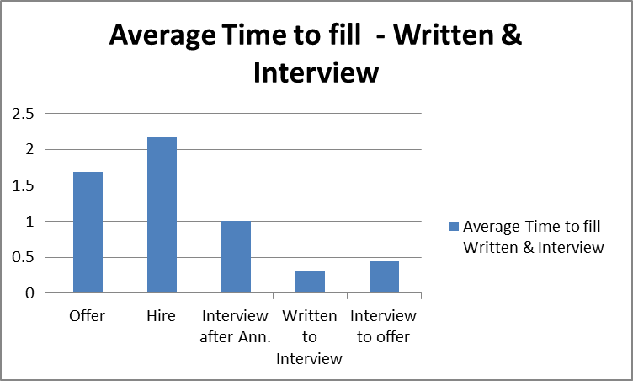
Source: HR Data, 2017
The graph shows that hiring process that passes through written and oral interview exam took an average of 1.68 months (50 days) to extend an offer and 2.17 months (65 days) to start the new jobs. These days has been calculated from the approval of the vacant post till offer acceptance and assum the new job. In order to identify problem if any, it is better to show the breakdown of the activities. Accordingly, we can see that in an average there is a 9 days (0.3 months) gap from written exam to interviews which is normal. These 9 days is used for marking the written exam and to invite the shortlisted candidate for interview. The graph also shows that after the candidates being interviewed, the recommended candidates will receive offer letter in an average after 0.44 months (13 days). The thirteen days is used for minutes of the meeting preparation and approval, background check at least two references, terrorist vetting, criminal investigation from federal police and other recruitment documentation preparation process. Generally, to complete the written and oral interview exam from the date of announcement ended took about one month.

4.7 Detail Average Time to Fill
Table 4.7.1 Detail Average Time to Fill Analysis -written & interview
 | Time to fill in days
Period | No. of Days –(Announcement to written) | Diff.% | No. of Days (Written-to-Interview) | Diff. % | No. of Days  (Interview to Offer) | %diff
2015/16 | 20 | 46 | 6 | 45.5 | 11 | 8.3
2016/17 | 37 | 46 | 11 | 45.5 | 12 | 8.3
Source: HR Data, 2017
The data shows that the average time taken for shortlising and to make ready candidates for written exam in the FY 2015/16 is 0,7 months (20days) and the time taken from written exam to interview is 0,2 month (6 days). The time taken from interview till issuing an offer took 0,4 month (11 days).
In the FY 2016/17, the average time taken for shortlising and to make ready candidates for written exam is 1,23 months (37 days) and the time taken from written exam to interview is 0,37 month (11 days). The time taken from interview till issuing an offer took 0,38 month (12 days).
In 2017 time taken for shortlisting till inviting the candidates raised from the previous year by 46%. The same thing to the time taken from written to interview It raised by 45,5% from the 2016. The time taken from interview to extend and accept the offer is raised by 8,3%. The reason for increasing the time to fill the FY 2017 was that there was only one HR Officer which manages all the recruitment process and becasuse the emergency posts need to be addressed first the other position should stay vacant for long period.

4.8 Average Time to Fill -Interview Only
The following graph shows the time taken to fill positions that passed through interview process only.
Figure 4.8 Average time to fill (interview only)
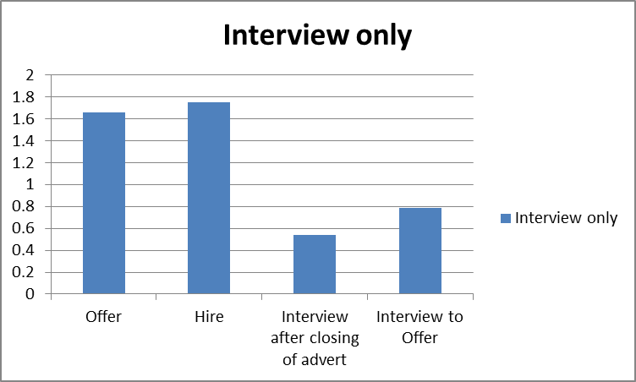
Source : HR Data, 2017
The graph shows that hiring process that passes through only oral interview exam took an average of 1.66 months (50 days) to extend an offer and 1.75 months (53 days) to start the new jobs. These days has been calculated from the approval of the vacant post till offer acceptance and assum the new job.
The graph also shows that after the candidates being interviewed, the recommended candidates expected to get offer of employment in an average after 0.79 months ( 24 days.) Most of the candidates who took only interview are emergency positions.
The 24 days are used for minutes of the meeting preparation and approval, background check of all emergency posts -at least two references, terrorist vetting, criminal investigation from federal police and other recruitment documentation preparation process. It is mandanotry for ChildFund to complete all these requirement. Those who meet the requirment , offer letter submitted Generally, to complete the oral interview exam from the date of announcement ended took about 0.54 months (16 days).

4.9 Detail Average Time to Fill
Table 4.9.1 The Detail Average Time to Fill Analysis (Interview only)
Period | Time to fill in months
Period | Time to offer | End of Advertisement to Interview | Interview to Offer acceptance | Offer to Hire
2016/17 | 1.63 | 0.65 | 0.15 | 0.15
2015/16 | 1.87 | 0.53 | 0.89 | 0.1
 | Source: HR report, 2017
From the data, 2016 /2017 recruitment process till offer extension completed within 1,63 months (49 days) while in 2015/2016 completed in 1,87 months (56 days) . This shows that there is a 14% (7 days) improvement to time to fill talents. Time taken for shortlisting and to make the candidates ready for interview in 2016/17 took 0,65 months (19 days) while in 2015/16 took 0,53 months (16days). This shows that shortlisting and to make talents ready for interview took little longer time than the pevious year which is 18,53% (4 days). The time taken from the period interview taken to extend an offer in 2016/2017 was 0,15 (4,4 days) while in 2015/2016 0,89 months (27 days). This shows that all the background check, clearance from federal police, terrorist vetting process has been completed. Time taken after acceptance of an offer until assuming a new job in 2016/2017 took 0,15 months (4 days) while in 2015/2016 took 0,10 (3 days). Here the recent year took little longer time by 1.5 days or 34,9%. This is the time that the new comers to complete the handling and taking process with their previous organization..

4.10 Time to fill by position
For the FY 201516 upto 2016/17, ChildFund Ethiopia has recruited professional and non profesional employee like Director, Manager, Specialsits, Coordinators, Officers, Assistants at country office level and also staff at Project levels. The followings are graphic demonistration of the average time elapsed in months between end of advertisment till offer acceptance and hired.
Figure 4.10 Average time to fill – Director Position
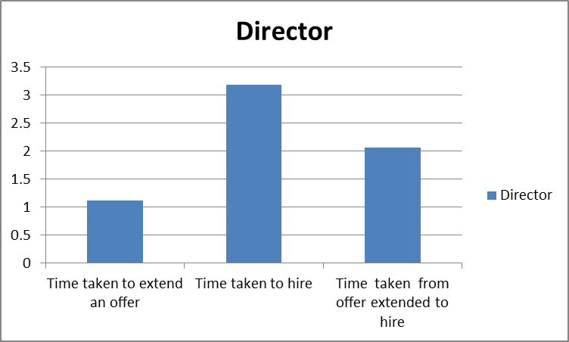
Source: HR Data, 2017

The graph shows that recruitment process i.e from vacant post approval to extend employment offer for the post of Director took 34 days but due to obligations to a former employer, which is beyond the recruiting team’s control, the job holder assumed the job after 62 days of accepting the offer.

Figure 4.11 Average time to fill – Manager Position
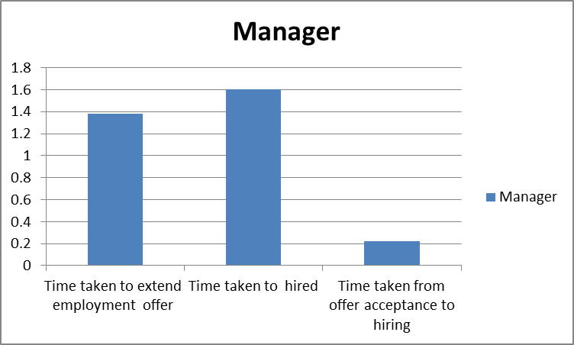
Source: HR Data, 2017
This graph that recruitment took about 1.38 months (41 days) to issue an employment offer and 1.6 ( 48 days )to start the job. The time period from accepting the offer letter to start the job took 0.22 months (7 days).

Figure 4.12 Average time to fill – Specialist Position
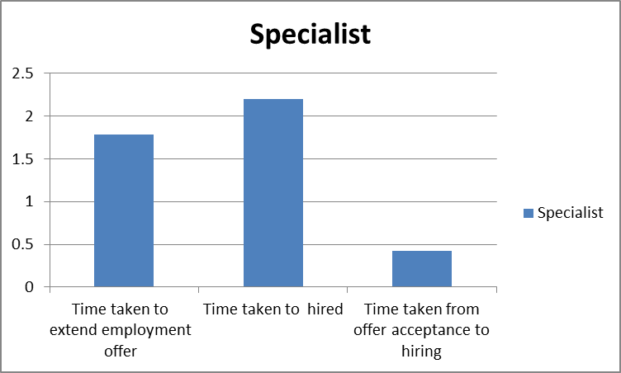
Source: HR Data, 2017

The graph shows that for specialist post 1.78 months (53 days) has been taken to issue an offer letter and 2.2 months (66 days) has been taken to hire. The time period after accepting the offer till hire took 0.4 months or 14 days. The positions have passed through written and oral interview.

Figure 4.13 Average time to fill – Officer Position
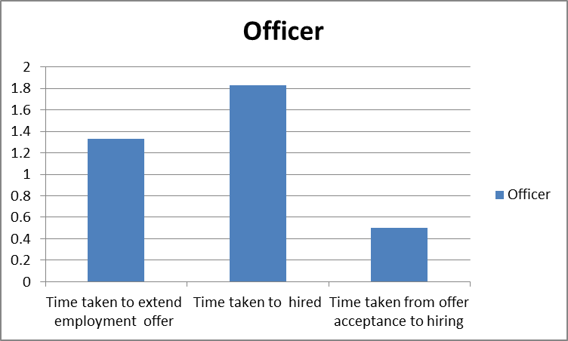
Source: HR Data, 2017
The graph shows that in average 1.33 months (40 days) has been taken to issue an offer for officer and 1.8 (55 days) to hire them. To start the job 0.5 monhts (two weeks) has been taken after accepting an offer letter
Figure 4.14 Average time to fill – Area Office Officer Position
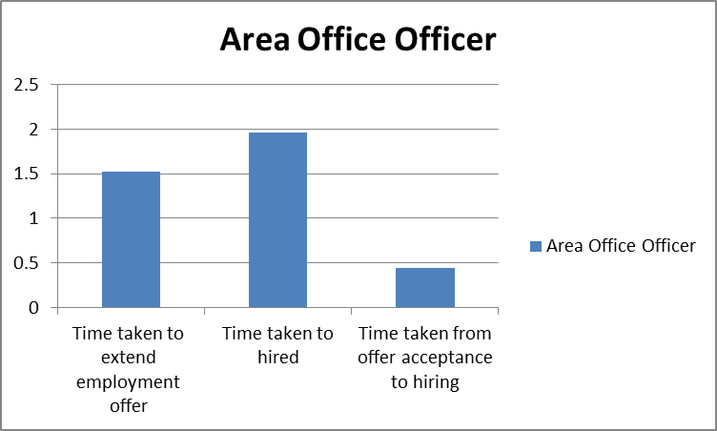
Source: HR Data, 2017

This graph shows that the officers position have taken 1.52 months (46 days) to issue an offer and 1.96 (59 days) to assume a new job. 0.44 months (13 days) has been taken by the job holders to assume the job after accepting the offer.
Figure 4.15 Average times to fill – Department Assistant Position
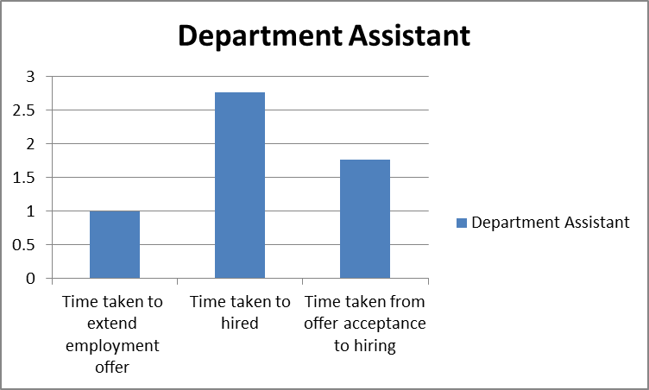
Source: HR Data, 2017

This graph shows that the department assistant position has taken 1 month (30 days) to issue an offer. In order to fill this position it took 2.76 (83 days) long. This is because the 1st recommended candidate has rejected the offer. This period also incorporate the approval process of the second candidate. The time taken from offer acceptance to hiring took 1.76 months (53 days). This is both for 1st recommended and 2nd recommended candidates.

Figure 4.16 Average time to fill – Driver Position
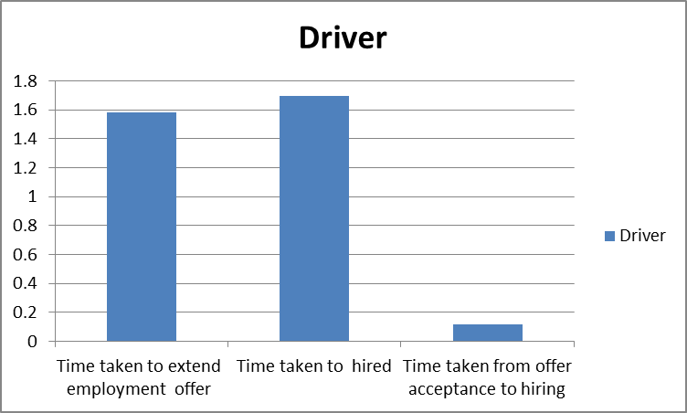
Source: HR Data, 2017
Data graph shows that Driver position has taken 1.58 months or within 47 days to extend an offer. The job holders assumed the new job in 1.69 months (51 days). Only 3 days has been taken by the job holders to assume the job after accepting the offer.

Emergency Project Positions
ChildFund Ethiopia is one of international organization which participate in the implementation of emergency response projects. For the FY 2015/16 and 2016/17, three projects has been implemented three projects such as Water Sanitation and Hygin (WASH) Community Based Management of Actute Malnutirtion (CMAM) and Child-well being projects. In order to implement the projects, ChildFund Ethiopia expected to recruited professional and non professionals. The following graph shows the time taken to fill all the required positions for that particular project.

Figure 4.17 Average time to fill – Emergency Project Positions
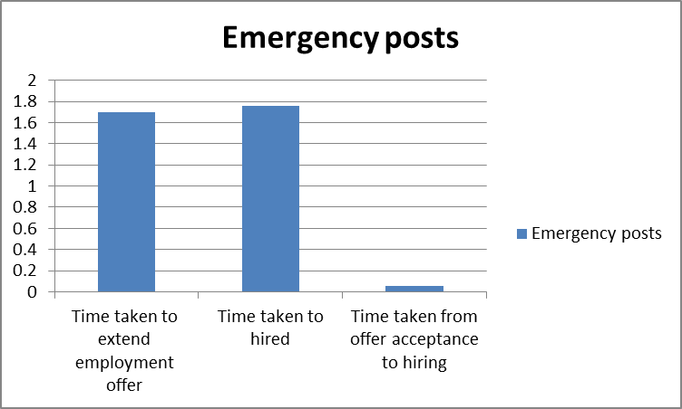
Source: HR Data, 2017
The graph shows that emergency program recruitment process till issuing an offer letter has been taken 1.7 months ( 51 days) . Almost all the emergency position assume their new jobs in an average in 1.76 months (53 days). They have started the job within two days of accepting their employment offer. This is due to the high cooperation of users departments with HRAD to effect the emergency recruitment timely

4.11 Costs per Hire (CpH)
The cost per hire recruitment metric adds up all the expenses that go towards hiring a new employee i.e. internal and external costs. CpH (Birr) = [Total External Costs] + [Total Internal Costs] / Total Number of Hires.
The internal cost which is fees to the salaries and benefits for talent acquisition staff i.e. hiring department and user department. The cost is calculated on the time spent for each hiring process i.e. from approval- announcement- shortlisting-, written and oral interview preparation and implementation and finally extending offer.
The study considered 40 hours in a week; which takes 8 hours in a day which is 8 hours in five days (8hrs x 5 days) = 40 hrs. in a week. So we will have 40 hrs times 4 weeks= 160 hrs./month. So the monthly gross salary and benefit given to a staff is to work for 160 hrs./month. So to calculate the cost for an hour will be the sum of salary and benefit divided by 160 hrs. . So the cost of hiring process activities will be determined accordingly.
Under this study, external costs are announcement costs which are online – ethiojob and newspaper costs.
The cost-per-hire details during the FY 2015/16 upto2016/ 2017 at ChildFund Ethiopia are presented as follows
Table 4.11 Recruitment cost
Total Recruitment Cost | = | Internal costs | + | External costs
396,123.4 | = | 233,497.13 | + | 162,626.27
- Total Cost
Source: HR Data +own calculation
- Recruitment Cost Detail
Type of costs | Details of internal and external recruitment costs | Total cost
Internal costs | Interview costs Br. 119,855.08  Written exam cost Br. 31,527.78  HR costs Br. 82,114.27 | 233,497.13
External costs | Newspaper Adv. Cost Br. 119386.27  Online Adv. Costs Br. 43240.00 | 162,626.27
Grand Total recruitment cost | 396,123.4 | 396,123.4
Source: HR Information+ own calculation
- Cost Per Hire
CpH= Total Recruitment cost/ Total No. of recruits
CpH= 396,123.4/172
CpH= 2303
The number of position were 172
The average cost-per-hire during the FY 2015/16 upto2016/ 2017 recruiting season is Birr 2,303.00. The breaking down average cost per hire per positions is shown below.

4.12 Average Recruitment Cost of Positions
Table -4.12.1 Average costs of positions at Country Office
Job Tile | July 2015-June 2016 |  | Total | July 2016 - June 2017 |  | Total | Grand Total
Job Tile | No. | Avg. Cost | Total | No. | Avg. cost | Total | Grand Total
Director | 0 | - | - | 1.00 | 8,609.94 | 8,609.94 | 8,609.94
Manager | 2 | 8,053.26 | 16,106.52 | - | - | - | 16,106.52
Specialist | 2 | 7,259.89 | 14,519.78 | 1.00 | 11,558.89 | 11,558.89 | 26,078.67
Officer | 5 | 6,813.21 | 34,066.05 | 1.00 | 2,210.42 | 2,210.42 | 36,276.47
Area Office Officer | 7 | 6,180.51 | 43,263.57 | 3.00 | 6,113.30 | 18,339.90 | 61,603.47
Finance Assistant | 0 | - | - | 1.00 | 9,683.75 | 9,683.75 | 9,683.75
Driver | 2 | 7,143.18 | 14,286.36 | - | - | - | 14,286.36
 | 18 | 6,791.24 | 122,242.28 | 7.0 | 7,200.41 | 50,402.90 | 172,645.18
Source: HR Data + own calculation
Under this study, Cost per hire applies not to be used purely as a reason to cut costs. The data shows that the total recruitment cost for the fiscal period 2015/16 upto 2016/17 for 172 positions is Birr 396,123. This is the sum of internal costs (HR staff, written, interview costs) - 233,497 plus external costs birr 162,626. The average cost-per-hire for recruiting during these periods was Birr 2,303. These costs include all positions including emergency positions

4.13 Recruitment cost at country office
The Average cost per hire in FY2015/16 is birr 6,791.24 while in 2016/17 is birr 7,200.42. This is due to increase in newspaper announcement cost. From the 18 position recruited for the FY 2015/16, the highest cost per hire was to recruit managerial position i.e. birr 8,053.26 and the smallest cost was birr 6180.51 for the recruitment of Area Office officers. In the FY 2016/17 out of the seven position hired, the highest cost of hire was Specialist position. This is due to the number and position of interview panels and newspaper advertisement cost which raised from the previous year. The panels for the recruitment of Specialist were directors, specialist and officer. The smallest cost per hire in this period was the recruitment of one officer. Here the panels were officers and a manager. The Finance Assistant position costs higher than the officers that the panel were Finance Director, Senior Finance officer and HR Officer plus newspaper cost. Generally, the cost per hire increased from the FY 2015/16 is birr 409.18 which is about 6% .

4.14 Recruitment costs at project office
The following table shows the average cost of all emergency positions recruited for the period July 2015 to June 2017.
Job Tile | July 2015-June 2016 |  |  | Total cost | July 2016 - June 2017 |  | Total |  |  | Grand Total
Job Tile | No. | Avg. cost |  | Total cost | No. | Avg. cost |  |  |  | Grand Total
Project Coordinator | 4 | 2,635.89 |  | 10,543.56 | 9 | 4231.08 | 38079.72 |  |  | 48,623.28
Nurse/WASH Project Coordinator | 4 | 2,178.09 |  | 8,712.36 | 7 | 2695.35 | 18867.45 |  |  | 27,579.81
TSFP Supervisor/Social Worker/Community Dev't Worker/Public Health | 32 | 860.60 |  | 27,539.20 | 42 | 1408.01 | 59136.42 |  |  | 86,675.62
Finance and Admin. Assistant | 4 | 2,197.17 |  | 8,788.68 | 6 | 2411.81 | 14470.86 |  |  | 23,259.54
Measurer/Registrar | 2 | 3,454.40 |  | 6,908.80 | 7 | 2363.91 | 16547.37 |  |  | 23,456.17
Cleaner/Guard | 11 | 479.23 |  | 5,271.53 | 19 | 453.29 | 8612.51 |  |  | 13,884.04
 | 57 | 1,188.84 |  | 67,764.13 | 90 | 1,730.16 | 155,714.33 |  |  | 223,478.46
Source: HR Information + own calculation
The data shows that the number of candidates recruited in 2015/16 was 57 while in 2016/17 was 90. This shows that recruitment of emergency project positions increased by 33 or by 37% from the FY 2015/16 with the same manpower. The cost per hire in the FY 2015/16 was birr 1,188.84 while in 2016/17 was birr 1730.16. This means it increased by birr 541.31 (31.29%). These increased is due to newspaper cost. The recruitment of Cleaner and Security Guards made by the project at the project site. The Country Office facilitates and verifies the recruitments follow proper recruitment procedures and requirements. Due to the fact that cost per hire is low.
Almost all recruitments have been done internally. If it has been made externally or through recruitment agency, the following cost will have been incurred. The recruitment agency i.e. ethiojobs requires a one month salary of the post per recruitment.

4.15 Comparison of internal recruitment costs with cost of

agency recruitment
Job Tile | No. | Recruitment cost by internal staff |  | Recruitment cost by recruitment agency |  | Difference
Job Tile | No. | Average cost | Total cost by position | Cost per position (basic salary of the post) | Total Cost
Director | 1 | 8,609.94 | 8,609.94 | 38,780.00 | 38,780.00 | 30,170.06
Manager | 2 | 8,053.27 | 16,106.53 | 32,317.00 | 64,634.00 | 48,527.47
Specialist | 3 | 8,692.89 | 26,078.67 | 26,931.00 | 80,793.00 | 54,714.33
Officer | 6 | 6,046.08 | 36,276.48 | 21,544.00 | 129,264.00 | 92,987.52
Area Office Officer | 10 | 6,160.34 | 61,603.40 | 17,236.00 | 172,360.00 | 110,756.60
Finance Assistant | 1 | 9,683.75 | 9,683.75 | 10,607.00 | 10,607.00 | 923.25
Driver | 2 | 7,143.18 | 14,286.36 | 5,893.00 | 11,786.00 | (2,500.36)
Project Coordinator | 13 | 3,740.25 | 48,623.25 | 21,544.00 | 280,072.00 | 231,448.75
Nurse/WASH Project Coordinator | 11 | 2,507.24 | 27,579.64 | 17,236.00 | 189,596.00 | 162,016.36
TSFP Supervisor/Social Worker/Community Dev’t Worker/Public Health | 74 | 1,171.29 | 86,675.46 | 13,788.00 | 1,020,312.00 | 933,636.54
Finance and Admin. Assistant | 10 | 2,325.95 | 23,259.50 | 10,607.00 | 106,070.00 | 82,810.50
Measurer/ Registrar | 9 | 2,606.24 | 23,456.16 | 8,485.00 | 76,365.00 | 52,908.84
Cleaner/Guard | 30 | 462.80 | 13,884.00 | 4,209.00 | 126,270.00 | 112,386.00
Total | 172 | 67,203.22 | 396,123.14 |  | 2,306,909.00 | 1,910,785.86
Source: HR Data, 2017
The above table shows that if all the positions recruited by recruitment agency, birr 2,306,909.00 would have been incurred i.e. a difference of Birr 1.9 million have been saved.

4.16. Promotion Speed of new hires
It is observed that employee promotion at ChildFund Ethiopia was through competition internally and externally and also through succession planning program. The following table showed the number of staff promoted vs the service year for the FY 2015/16 in relation with the average number of staff at that particular period i.e. 68. The employee promotion considered only staff at country office. Here employee at project level was not been considered.

 | Table 4.16.1 Promotion speed of new hires for FY 2015/16
No. of Promotion | Service at ChildFund Ethiopia |  |  | Avg. No. of staff at CO /month/ period |  | Position Promoted
2 | 2 to 3 years |  |  | 68 |  | Specialist/Sr. Officer
3 | 7 to 19 years of service |  |  |  |  | Specialist/Sr. Officer
5 | Total promoted → % |  |  | 7.35 %
Source: HR report, 2017

 |  | Table 4.16..2 Promotion speed of new hires for FY 2016/17
No. of Promotion |  | Service at ChildFund Ethiopia | Avg. No. of staff at CO/month/ period |  | Position Promoted
1 |  | 1 to 2 years | 62 |  | Director
5 |  | 2 to 3 years |  |  | Specialist/Sr. Officer
5 |  | 4 to 10 years |  |  | Officer/Specialist/Sr. officer/Sr. Supervisor
11 |  | Total promoted in → % | 17.74%
Source: HR report 2017
The above table shows that the percentage of staff promotion for the FY 2015/16 has been increased by 59% from FY2015/16. For the FY2015/16 only five staff has been promoted to Sr. Officer/Specialist level out of which two staffs (40%) were less than three years of service at ChildFund of Ethiopia. The rest 60% were staffs served more than 7 years of service at ChildFund Ethiopia. While in the FY 2016/17 eleven staffs have been promoted. Among these staff 5 staff (45.45%) served ChildFund less than three years and also the same number between 4 to 10 years of service. and only 1staff (9%) has less than two years of service Here emergency project staff have not been incorporated as their recruitment is short and fixed period i.e. six to 12 months.

This shows that promotion speed of new entrants is improved. As the employees recruited are potentially capable to assume higher responsibilities, they aspire change in position and need to be continued.

4.17 Turnover
Employees leave ChildFund Ethiopia due to different reasons such as resignation, termination of contract, job cancellation, retirement, death and sickness. The following are turnover analysis for the period July 2015 upto June 30, 2017.
Table 4.17.1 Reason for leaving ChildFund Ethiopia
Turnover | No. | Percentage
Resignation | 38 | 60%
Project phase-out | 19 | 30%
Job cancellation | 3 | 5%
Death and Sickness | 2 | 3%
Pensioned | 1 | 2%
Total | 63 | 100%

The above data shows that out of the total number of turnover - 63 employees, 38 of them (60%) are resignation while 19 employees (30%) of the total turnover of employees are due to project phase-out. The rest 5%, 3% and 2% respectively are job cancellation, Death/Sickness and retirement, respectively. Turnover due to resignation has the highest percentage from the rest of the others and need to be seen in details so as to find the reason for the resignations as it has a big impact towards the success of an organization. Accordingly this study tried to see who and for what reason employees resigned by their own accords.

Table 4.17.2 Turnover Analysis for staff served less than one year

Period | Total No. of staff resigned | Avg. No. of all staff /month/ period | Turnover rate (%) | Total Turnover cost | Resignation at Country Office | Avg. No. of staff at CO /month/ period | Turnover rate | Resignation at Emergency | Avg. No. of staff at Project /month/ period | Turnover rate | Staff served less than one year
 |  |  |  |  |  |  |  | Project Level | Avg. No. of staff at Project /month/ period | Turnover rate | Country Office | Project | Total resigned | Total turnover cost | Turnover rate (%)
2015/2016 | 14 | 86 | 16 | 32,242.00 | 4 | 68 | 5.9 | 10 | 18 | 56 | 3 | 6 | 9 | 20,727.00 | 10
2016/2017 | 24 | 121 | 20 | 55,272.00 | 7 | 62 | 11 | 17 | 60 | 28 | 3 | 17 | 20 | 46,060.00 | 17
Source: HR data, 2017

The data shows that turnover rate increased from 16%to 20% from 2015/16 to 2016/17. This means that turnover rate increased by 18 %. The same thing happened for the cost. The turnover cost that means the cost to recruit the replacement due to resignation increased from 32,242 to birr 55,272.00. This has been calculated taking into account the average cost per hire calculated above i.e. Birr 2303 multiplying by the number of staff resigned by their own accord.
In 2015/16, the total staffs resigned were 14 out of which four were from country office and the rest ten from project. For this period, the turnover rate for staff resigned less than one year was 10% and the cost incurred was birr 20,727.00.
For the period 2016/17, the turnover rate was 20% i.e. total staffs resigned were 24 out of which 7 from country office and the rest 17 from the emergency projects. For the FY 2016/17 the turnover rate for staff resigned less than one year was 17% and birr 46,060.00 of turnover cost. From exist questionnaire made by the organization; the reason for leaving was salary and benefits packages as the time period are fixed.
As most of the emergency projects‘ life period is six months, this paper also tried to further see the average voluntary turnover rate of new hires less than six months compared to the average voluntary turnover rate of new hires from FY2016/17 from FY 2015/16. The following table described the details.
Table 4.17.3 Turnover analysis for staff less than 6 months
Period | Total No. Staff resigned | Avg. No. of all staff /month/ period | Turnover rate | Turnover Total Cost | Staff served less than six month
 |  |  |  |  | No. of staff resigned at Country Office | Turnover rate (%) | Emergency Project | Turnover rate (%) | Total Turnover rate | Turnover cost
2015/2016 | 14 | 86 | 16 | 32,242.00 | 0 | 0 | 5 | 6 | 6 | 11,515.00
2016/2017 | 24 | 121 | 20 | 55,272.00 | 1 | 1 | 9 | 7 | 8 | 23,030.00
Source: HR Data, 2017
The table shows that from the total turnover rate 16% for the FY 2015/16, 6% of them were professional emergency project staff who served less than six months. Out of the 20% resigned staff for the FY 2016/17, 7% were from emergency project staff and 1% from country office - Officer. This shows that from staff resigned within a year, 60% of them are staff served less than 6 months for the FY2015/16. For the FY2016/17, 47% of the staff resigned less than 6 months. This means that there is high movement of emergency staff which needs to be revisited. For the period 2015/16, birr 11,515.00 is incurred for the replacement of candidates who left less than 6 months. Birr 23,030 is also incurred for the period 2016/17.

4.18 Quality of Hire (QoH)- Effectiveness Metrics
Quality of Hire measures the value new hires bring to the ChildFund Ethiopia. Here value means how much a new hire contributes to ChildFund Ethiopia strategic objective by completing tasks, improving their work and helping others.

This paper tired to identify Quality of Hire interms of the following metrics indicators.
- Manager satisfaction on new hire performance metrics ( Post Hire)
- Pre-Hire Quality
- Promotion Speed of new hires
- Turnover

4.18.1 Manager satisfaction on new hire performance
In order to identify the performance of new hire, questionnaires were distributed to all managerial positions at ChildFund Ethiopia. The managerial positions were as follows.

Table 4.18.1 List of Line Managers
Managerial position | No. of managers
Area office managers | 3
Country Office Mgr. | 2
Director | 4
Project Coordinator | 3
Total Sum | 12
Source: Post Hire Survey, 2017

As shown in the above table, questionnaire on post hire weredistributed for the above 12 managers. The respondants were asked whether they are satisfied with the recruitment process and the new hire performance using the following ratings.
Ratings :-
- Unacceptable
- Partially meet expectation
- Meet Expectation
- Exceed Expectation
- Outstanding
Table 4.18.2 Respondents‘ view on post hire survey
Manager | No. | Quality of candidates | Communications | Time to fill | Advice on Hiring process | Recruitment panel formation/competency | Type of interview and written exam | Induction Program | Overall evaluation of recruitment
Area Office mgr. | 1 | 3 | 3 | 3 | 2 | 2 | 3 | 2 | 2.6
Area Office mgr. | 1 | 4 | 4 | 4 | 0 | 4 | 4 | 2 | 3.7
Area Office mgr. | 1 | 3 | 4 | 4 | 3 | 3 | 3 | 2 | 3.1
Director | 1 | 3 | 3 | 3 | 3 | 3 | 3 | 3 | 3.0
Director | 1 | 3 | 3 | 3 | 3 | 3 | 3 | 3 | 3.0
Director | 1 | 3 | 3 | 3 | 3 | 3 | 3 | 3 | 3.0
Project coordinator | 1 | 4 | 4 | 4 | 4 | 3 | 3 | 4 | 3.7
Project coordinator | 1 | 3 | 4 | 3 | 0 | 3 | 3 | 5 | 3.5
Project coordinator | 1 | 4 | 4 | 4 | 4 | 3 | 3 | 4 | 3.7
Total Sum | 9 | 30 | 32 | 31 | 22 | 27 | 28 | 28 | 28.3
Avg. |  | 3.3 | 3.6 | 3.4 | 2.4 | 3.0 | 3.1 | 3.1 | 3.1
Source: Post Hire Survey, 2017

From among the 12 respondents, nine of them responded the questionnaire. From the managers’ response, it is found out that the overall evaluation of recruitment has met expectation i.e. an average of 3.1. From among the evaluation criteria, Communication throughout the recruitment process ranked 1st i.e 3.6 and time to fill - 3.4. The minimum rating was the recruitment panel formation and their competency i.e. 3.0 (which is under meet expectation category). From among the criteria which need to be improved is Induction program. 33% of the managers have showed their concern on the improvement of induction program for new entrants. In the areas of evaluation criteria, acquiring quality of candidates has 3.3 which is meet requirement. This shows that the new hire performance has met the required quality/skill

4.18.3 Pre-hire Analysis
Pre-hire Quality can tell us how employee has satisfied with the recruitment process. In addition to managerial satisfaction on the new hire performance, employee satisfaction on the recruitment process has also been included to get the full picture of measuring quality of hire. Focusing on pre-hire metrics helps employers focus on specific souces of hiring . The questionnaire tried to evaluate how the current recuitment process achieve the organizational objectives. The element encorporated in the questionnaire were the clarity of vacancy announcement, interview and writen exam preparation, responsiveness and support of hiring department during recruitment, the practice of induction at hiring department and other department, acquring necessary tools for work and the similarity of job description vs actual work. Employees showed their satisfaction and dissatisfactionn on the crieteria set. This paper tried to find and clarify any concerns/dissatisfaction rated more than 5%. the The followings are the rate of return of questionnaire distributed.

Table 4.18.3 Respondents‘ view on pre hire survey
Description | Very Satisfied |  | Satisfied |  | Not Satisfied |  | Questions not answered |  | Total
Description | No. | % | No | % | No | % | No | % | No | %
Clarity of job posting | 36 | 44 | 42 | 52 | 2 | 2 | 1 | 1 | 81 | 100
Written exam preparation | 30 | 37 | 12 | 15 | 3 | 4 | 36 | 44 | 81 | 100
Oral Interview preparation | 51 | 63 | 21 | 26 | 0 | 0 | 9 | 11 | 81 | 100
Initial contact with HRAD | 33 | 41 | 45 | 56 | 0 | 0 | 3 | 4 | 81 | 100
Response time from HRAD | 42 | 52 | 24 | 30 | 6 | 7 | 9 | 11 | 81 | 100
1st day of orientation at HRAD | 33 | 41 | 42 | 52 | 3 | 4 | 3 | 4 | 81 | 100
Orientation at other department | 27 | 33 | 45 | 56 | 9 | 11 | 0 | 0 | 81 | 100
Support from HRAD in hiring process | 30 | 37 | 42 | 52 | 3 | 4 | 6 | 7 | 81 | 100
Welcome by respective departments | 42 | 52 | 30 | 37 | 3 | 4 | 6 | 7 | 81 | 100
Competency of co-workers for new hires | 33 | 41 | 42 | 52 | 0 | 0 | 6 | 7 | 81 | 100
Acquire necessary tools for work | 36 | 44 | 30 | 37 | 9 | 11 | 6 | 7 | 81 | 100
Job description vs actual work | 24 | 30 | 51 | 63 | 0 | 0 | 6 | 7 | 81 | 100
Source: Pre hire survey, 2017
With regard to the accuracy and description of the job posting are very satisfied by 44% of staff and some how satisfied by 52% of the staff. 2% of the staff showed their disatisfaction on the accuracy and description of the job posting. The remaining 1% didn’t respond.
37% of the employee are very satisfied by the written exam given by ChildFund Ethiopia and 15% of employees are some how satisfied. Only 4% shows their disatisfaction.. The remaining 44% didn’t answer this question as most of them do not take written exam.

With regards to oral interview, disatisfaction has not been found. About 63% are very satisfied and the rest 26 % are some how satisfied by the oral interview procedures. The remining 11% did not answer the questions.
41% of the employees are very satisfied with the information received about the recruitment process and 56% are some how satisfied. The remaining 4% do not respond. There are no employees shows their disatisfaction regarding recruitment information during the recruitment process.
52% of the employees are very satisfied with the response time from the recruiting department processing applications. 30% of the employees are some how satisfied. However, 7% of the employees showed dissatisfaction with ther response time in processing the applications. These dissatisfaction occured due to the fact that there were manpower needs for emergency projects to be filled immediately and given prirorities to fill the vacant posts and then latter the other post continued. These recruitments have been handled by one HR Officer. The remaing 11% do not give response

41% of the employees are very satisfied in the 1st day of orientation at HRAD and 52% of the employees are some how satisfied. 4% of the employees have shown their dissatisfaction on the 1st day of orientation at HRAD. The remianing 4% , do not respond.
Regarding orientation at the other work units, 33% of the employees are very satisfied and 56% of the employees are some how satisfied. However 11% showed their dissatisfaction on orientation in other department. The reason for the dissatisfaction were the orienttion were not comprehensive, programmed/planned.
37% of the employees confirmed that they have got support from HRAD throughout the hiring process and they are very satisfied . 52% of the staff are some how satisfied. 4% of the staff showed their dissatisfaction. The remaining 7% do not answer the question.
52% of the employees have been wolcomed by their departments and they are very satisfied and 37% are some how satisfied. 4% of the employees showed their disatisfaction. The remaining 7% do not respond.
From the data collected 41% of the employee are very satisfied because they are assigned with coworkers that have right competency and 56% of employees are some how satisfied with the competency of coworkers for new hires. No employees showed their dissatisfaction on the competency of coworkers for new hire. The remaining 7% do not answer the question.
44% of the employees are very satisfied in acquirinng necessary tools for work and 37% are some how satisfied. 11% of the employees shows their disatisfaction in acquiring the necessary tools for work. The remaining 7% do not respond.
30% of the employees are very satisfied with their job description compared to what they are actually doing. The rest 63% of the employees are some how satisfied. There is no dissatisfaction in job description compared to actual work.

Table 4.18.4 Respondents‘ view on ChildFund a place to work
Questions | Response | Frequency | %
ChildFund a place to work | Strongly agree | 0 | 0
ChildFund a place to work | Agree | 54 | 67
ChildFund a place to work | Strongly disagree | 0 | 0
ChildFund a place to work | Disagree | 3 | 4
ChildFund a place to work | Neither/nor | 6 | 7
ChildFund a place to work | Missing questions | 18 | 22
ChildFund a place to work | Total | 81 | 100
Source: Pre hire survey, 2017
Accordingly, 67% of the respondents agree to recommend ChildFund as a good place to work while 4% responded disagree. The remaining 7% neither agree nor disagree. The remaining 22% do not answer the question. There is no respondent that shows strongly disagree and strongly agree.

Table 4.18.5 Respondents‘ view on induction of new entrants
Description | Yes |  | No |  | Not responded |  | Total
Description | No | % | No | % | No | % | No | %
Orientation | 72 | 89 | 3 | 4 | 6 | 7 | 81 | 100
Pre Hire Survey, 2017
The above table shows that the majority of respondents i.e. 89% responded that they have taken orientation during their entrance but 4% of the respondents shows that they do not take induction. The remaining 7% do not answer the questions
Table 4.18.6 Respondents‘ view on means of recruitment
Questions | Response | Frequency | %
Means of recruitments | News paper | 24 | 30
Means of recruitments | Online | 39 | 48
Means of recruitments | Recruitment Agency | 3 | 4
Means of recruitments | Employee Referral | 3 | 4
Means of recruitments | Rehire | 3 | 4
Means of recruitments | Missing questions | 9 | 11
Means of recruitments | Total | 81 | 100
Source: Pre Hire Survey, 2017
The above table shows that that 48% (39 respondents) of the employees recruited through online (electronically) and 30% (24 respondents) of the employee recruited through newspaper. The rest 4% each (4 respondent each) through employee referral, Recruitment agency and re-hire. These showed that most vacant posts are visited by potential candidates mostly by electronically and followed by newspaper. This shows that ChildFund Ethiopia uses different means of recruitment so as to reach potential candidate amongst which online and through newspaper are common means of recruitment. The other means are alternative incase potential candidates not found.

CHAPTER FIVE

SUMMARY OF FINDINGS, CONCLUSIONS AND RECOMMENDATIONS

Having reviewed the relevant literature and analyzed the data collected, the final chapter of the research presents findings, conclusion and possible recommendations.

5.1 Summary of Findings
The following findings were obtained.
- Miss match of HR staff vs number of recruits and number of employees
- ChildFund Ethiopia doesn’t apply HR metrics to evaluate the efficiency and effectiveness of HR activities like recruitment so as to make recruitment related decision.
- .The quality and load of current HR works have not recognized by ChildFund Ethiopia
- In order to recognize the efficiency of recruitment, the average time to fill , promotion speed of new entrants, turnover and cost per hire have been identified.
- With scares HR staff, the time to fill the vacant posts have met managers’ expectation.
- ChildFund incurs minimum cost for recruitment
- With regards to overall evaluation of recruitment, ChildFund meets expectation
- ChildFund provides induction program for all entrants but the quality of induction needs to be improved.

5.2 Conclusion
This study introduced the important of HR metrics on the recruitment process. It assessed the current recruitment process at ChildFund Ethiopia and identified the strength and weakness of recruitment process using efficiency and effectiveness metrics for candidates recruited from the FY2015/15 upto 2016/17. The efficiency metrics were the Time to Fill and Cost per Hire, promotion speed of new hires and turnover while the effectiveness metrics are post and pre hire evaluation.

5.3 Recommendation
The following recommendations are forwarded at least to minimize the problems encountered.
- ChildFund should apply HR metrics so as to evaluate the efficiency and effectiveness of HR activities.
- ChildFund has to assign adequate HR personnel to fill the available vacant post within the appropriate period.
- In order all the employee recommends ChildFund a place to work and to minimize employee turnover, ChildFund should recognize/ promote/award good performance employee and compensate accordingly with salary and benefit packages
- As Induction is the first impression for new entrant and help to retain employee, it must be done by all department in an organized and planned way.
- Since the necessary working tools is mandatory for new entrant to deliver the output , HRAD should provide the necessary working tools like appropriate laptops and the needed accessories, place to sit and appropriate office furniture to the new employee on time.
- To move our recruitment to perfection, ChildFund should prepare written exam more practical than theoretical.
- Better to review the job description (JD) of all positions so as to make the JDs better matched with the employees who are actual working.

Bibliography

Alec Rodger and John Munro, The Seven-Point Plan and the Five-fold Grading System. Retrieved August 2017, from http://voyager8.blogspot.com/2016/06/rodger-7-point-plan-and-munro-5-fold.

Aleksey Savkin. (2015), Time to Fill. (LinkedIn, @bscdesigner). Retrieved August 2017, from https://bscdesigner.com/replace-time-to-fill-hr-kpi.htm

Bersin by Deloittee. Retrieved September 2017, from https://www.linedin.com/pluse/recruting-how-important-cost-per-hire-david-green

Beverly Kay I, Lindy Williams I Lynn Cowart. (1997). Rethinking Career Mobility. Berrett-Koehler Publishers, Inc. Page 6 and 7. Retrieved August 2017, from www.bkconnection.com

Catherine Rampell. (2013). With positions to fill, employers wait for perfection. The New York Times.

Chirantan Basu. (1995). How to Calculate the Employee Turnover Rate on an Annual Basis. Retrieved August 2017, from http://smallbusiness.chron.com/calculate-employee-turnover-rate-annual-basis-10202.html

Colin Beames (2014). Advanced Workforce Strategy. Yorkshire Business Complex 1-21 Robert Street, Collingwood, VIC 3066, Australia.

Donald Asher. (2014). Careers and Higher Education, (2nd ed,) Ten Speed Press,
Page 208.

Emily Smykal. (2015). Recruitment metrics, Measuring Time to Fill.

Erik Van Vulpen. (2016). The basic principles of people (1st ed.). HR Analytics Create Space Independent Publishing Platform.

Filippo Berio - Wikipedia. Retrieved August 2017, from https://en.wikipedia.org/wiki/Filippo_Berio

Jane Weightman. (2003). Managing human resources. Mumbai,Delihi, Kolkata: Jaico Publishing House.

Mirza S. Salyadain. (2004). International management institute (3rd ed.). New Delhi: Tata McGraw-Hill Publishing Company Limited, 72-78.

Nick Boulter, Murray Dalziel and Jackie Hill. (2005). People and competencies- a handbook. NewDelhi: Crest Publishing House, 129-138.

P.Plumbley. (1991). Recruitment and selection (5th ed.). London.

Recruitment Benchmark Survey Results. (2013). Novo Group.
Rynes, S. L., & Cable, D. M. (2003). Recruitment research in the twenty-first century. In W. C. Borman, D. R. ILgen, & R. J. Klimoski (Eds.), Handbook of Psychology, 12, 55-76.

Savkin ( LinkedIn, @bscdesigner. Retrieved August 2017, from https://bscdesigner.com/replace-time-to-fill-hr-i.htm

Shalamarks (2014). The”what” and “How” of calculating Recruitment Costs.

Shanil Kaderali. (2013). How to measure whether you’re hiring good people.
Srinivas R. Kandula (2004) Corporate HRD. New Delhi, 351-353.

Srinivas R.Kandula. 2004 Human Resource Management in practice: with 300 models, techniques and tools (1st ed.). Retrieved from https://www.gettextbook.com/authjor/srinivas_r_kandula

Subramuniam and Devi (1984) Wikipedia. Retrieved August 2017, from https://en.wikipedia.org/wiki/List_of_Padma_Shri_award_recipients_(1980%E2%80%93198

The Wall Street Journal, Are Your Turnover Rates Hurting Your Cost Containment Strategy? Retrieved August 2017, from https://www.staffmanagement.com/are-your-turnover-rates-hurting-your-cost-containment-strategy

Time to Fill. SHRM. ( 2004).

Work Plan (Gantt chart)

Activities to be done | Year 2017
Activities to be done | July | August | September | October | November
Prepare project proposal
Library reading
Preparation of questionnaire and collection of relevant HR data
Analysis of quantitative data and summarizing the qualitative data
Write up of dissertation
Submission of first draft to the supervisor
Incorporation of comments from the supervisor and submission of final draft

Appendix A

INDRA GANDHI NATIONAL OPEN UNIVERSITY
MAIDAN GARHI, NEW DELHI-110068

Questionnaire

Researcher: Sara Negussie (MPA)
Advisor: Dr. Elias Berhanu
Research Topic: The important of HR metrics in the recruitment process: Case of ChildFund Ethiopia

Dear Respondents

This study is conducted for the partial fulfillment of the requirements for ChildFund Ethiopia recruitment practices. The information you provide will keep confidential and will be used for this research purpose only. Your honest and strait forward response is higher important and would contribute the success of the study.

General Guideline
- No need of writing your name
- Please put a circle on those questions that are followed by choices and write your short and precise answer for those followed by blank space ( i.e. open ended questions)
- For questions that demand your opinion, please try to honestly describe as per the questions on the space provided.
Contact Address:
If you have any question, please do not hesitate to contact me and I will be available as per your convenience on my email address (saranegu@yahoo.com)

Thank you very much for your cooperation in advance

Recruitment Satisfaction Survey

Part I Basic Demographic Data

1. Sex
- Male
- Female
2. Age
- Less than 25
- 25 to 30
- 31 to 35
- Above 35
3. Education
- High school
- Diploma
- First Degree
- Second Degree (Masters)
- Other, specify _______________________
4. Age
- Less than 25
- 25 to 30
- 31 to 35
- Above 35
5. Location
- Country Office
- Project Office

6. How long have you been working at ChildFund Ethiopia
- Less than one year
- 2 to 5 year
- 5 to 10 years
- Above 10 years

- Can you specify your job tile___________________________

Part II - Information on effective and efficient recruitment practice

- How were you recruited to ChildFund Ethiopia?
  - Employee Referral
  - External Recruitment Agency
  - Re-hire
  - Online (e-recruitment)
  - Newspaper

- How satisfied were you with the accuracy and description of the job posting?
- Very satisfied
- Satisfied
- Not Satisfied
- If dissatisfied, please tell us why and how it should be posted ________________________________________________________________________________________________________________________________________________

- How satisfied were you with the written exam with ChildFund Ethiopia
  - Very satisfied
  - Satisfied
  - Not Satisfied
- If dissatisfied, please tell us why and how it should be conducted ________________________________________________________________________________________________________________________________________________

- How satisfied were you with the oral interview process with ChildFund Ethiopia
  - Very satisfied
  - Satisfied
  - Not Satisfied
- If dissatisfied, please tell us why and how it should be conducted ________________________________________________________________________________________________________________________________________________

- During your initial contact with the recruiting department, how satisfied were you with the information received about the recruitment process?
- Very satisfied
- Satisfied
- Not Satisfied
- How satisfied were you with the response time from the recruiting department processing applications/resumes?
  - Very satisfied
  - Satisfied
  - Not Satisfied
- Did you receive new hire orientation?
  - Yes
  - No
- How satisfied are you with the first day/week new hire orientation at recruiting department?
  - Very satisfied
  - Satisfied
  - Not Satisfied
- If dissatisfied, please tell us why and how it should be conducted ________________________________________________________________________________________________________________________________________________

- How satisfied are you with the first week new hire orientation at other departments?
  - Very satisfied
  - Satisfied
  - Not Satisfied
- If dissatisfied, please tell us why and how it should be conducted ________________________________________________________________________________________________________________________________________________
- Did the recruiting department assist you to your satisfaction throughout the hiring process?
  - Very satisfied
  - Satisfied
  - Not Satisfied
- How satisfied were you with the welcome you received from your department?
  - Very satisfied
  - Satisfied
  - Not Satisfied
- If dissatisfied, please tell us why and how it should be conducted ________________________________________________________________________________________________________________________________________________
- How satisfied were you with the knowledge and skill of your assigned co-worker?
  - Very satisfied
  - Satisfied
  - Not Satisfied
- How satisfied are you with the necessary tools (office, office equipment, furniture) provided to complete your job
  - Very satisfied
  - Satisfied
  - Not Satisfied
- How satisfied are you with how the job was described in your Job Description compared to what you actually doing?
  - Very satisfied
  - Satisfied
  - Not Satisfied
- Could you recommend ChildFund as a good place to work?
  - Strongly agree
  - Agree
  - Neither agree or disagree
  - Disagree
  - Strongly disagree

- What could the recruitment department have done to make this hiring process more efficient and effective? ________________________________________________________________________________________________________________________________________________

- Please share any additional feedback or recommendations you may have
-----------------------------------------------------------------------------------------------------------------------------------------------------------------------------------------------------------

Thank you!

Appendix B
Questionnaire II

Researcher: Sara Negussie (MPA)
Advisor: Dr. Elias Berhanu
Research Topic: The importance of HR metrics in the recruitment process: Case of ChildFund Ethiopia

Dear Respondents

This study is conducted for the partial fulfillment of the requirements for ChildFund Ethiopia recruitment practices. The information you provide will keep confidential and will be used for this research purpose only. Your honest and strait forward response is higher important and would contribute the success of the study.

General Guideline
- As expressed on the above no need of writing your name
- Please put a rate ( 5 to 1) inside the box and write your short and precise answer for those followed by blank space
- For questions that demand your opinion, please try to honestly describe as per the questions on the space provided.
Contact Address:
If you have any question, please do not hesitate to contact me and I will be available as per your convenience on my email address (saranegu@yahoo.com)

Thank you very much for your cooperation in advance

Manager Satisfaction Survey

Part I Basic Demographic Data

1. Sex
- Male
- Female
2. Education
- First Degree
- Second Degree (Masters)
- Other, specify _______________________
3 . Location
- Country Office
- Project Office

Part II Information on quality of hire

Rating Scale:

1 – Unacceptable
2 – Partially Meets Expectations
3 – Meets Expectations
4 – Exceeds Expectations
5 – Outstanding

Areas of Evaluation | Rating (1-5)
Quality of Candidates (Educational background/ relevant experience and required competencies/behavior/attributes etc.
for the assigned job)
Communication throughout the recruitment process
Timeframe from beginning of recruiting to hire date
Recruiter’s impact via advice on candidates and the hiring process
Recruitment panel formation and their competency
The type of written questions/oral interviews exam
Induction Program for new entrants
Overall Evaluation of Recruitment

Additional Questions/Comments:

How much time taken for written exam preparation?
What are areas for Recruiting to improve in the hiring process?

Additional Comments:

Thank you!

Proposal
DISSERTATION PROPOSAL

Candidate’s: SARA NEGUSSIE
Program Code: MPA
Course Code: MPAP-002
Enrolment No: ID1219209

Regional Center_______________

Study Centre ________________

Study Centre Code________________

Address:
Bole Sub City, Woreda 4, House No. 060
Tel.No. 251-911 13 38 22/ 0911 40 92 32
E-mail: saranegu@yahoo.com

Title of the Dissertation: The importance of Human Resource Metrics on recruitment process: Case of ChildFund Ethiopia

CERTIFICATE OF APPROVAL

I hereby certify that the proposal for the Dissertation entitled ‘” The importance of HR Metrics on recruitment process: Case of ChildFund Ethiopia by Sara Negussie has been prepared after due consultation with me. The proposal has my approval and has, to my knowledge, the potential of developing into a comprehensive Dissertation Project. I also agree to supervise the above-mentioned Dissertation till its completion.
(Signature of the Academic Supervisor)
Name: ____________________________
Designation _________________________
Address: Telephone No 0911 63 07 22

I. Introduction
1.1 Background of the Study
In any organization regardless of its type, there is a key resource without which it cannot be achieved its objectives. It is the human capital. Talent acquisition is one of the most urgent issues for any organization and the pressure to hire the right people has created an intensely competitive recruiting environment. The talent acquisition departments are expected therefore to take on a more analytical approach to hiring by tracking key recruitment metrics.

In this case it will be important for an organization to apply HR metrics to demonstrate to what extent HR activities meet defined e priorities needs for the organization and support the overall organizational objectives. This allows the organization’s leadership team to develop and align the HR strategy to the strategies of other departments, and to integrate the HR strategy within the personal objectives of the HR team.

This paper focuses on examining the current practice of recruitment process at ChildFund and its assessment. It also indicates solution for the problem and recommends possible strategies to improve the situation. ChildFund Ethiopia is one of the most respected child protection and development organization in the world, is a nonsectarian charitable organization dedicated to serving the needs of children worldwide. ChildFund Ethiopia works to assist and protect children in emergency situation and disasters. For the last two years ChildFund Ethiopia has recruited 169 staffs out of which about 151 are emergency staff recruited using proper recruitment process using one HR Officer. Currently, ChildFund Ethiopia has a total staff of 101. If emergency program continues, ChildFund Ethiopia will be facing problem in effecting proper recruitment and achieve its objective. The main cause of this problem is inadequate HR professional which brings the quality of hire low. So it is critical issue to raise the problem of acquiring adequate, qualified and engaged HR professional in the HR department.

1.2. Statement of the Research Problem
Human Resource (HR) metrics is a measurement of human resources data into meaningful information about the human capital. So, it helps us to track and measure performance of HR functions like recruitment & selection, performance, turnover, etc.

As we know human capital is one of the least measured and analyzed investments, despite the fact that the highest percentage of the company costs are labor related. Thus, HR metrics should be practiced by organizations so as to assess the performance of HR functions which finally leads an organization towards success.

So the purpose of this work is to assess the recruitment process of ChildFund Ethiopia as a major HR function. Even though, efficient and effective recruitment process is one of the major HR functions which leads organization towards success, ChildFund Ethiopia couldn’t recognize it which finally results in HR staff dissatisfaction due to mismatch of HR staff vs total number of employees.

In order to find out solution, the researcher has planned to quantify the recruitment process activities in terms of number or percentage. As it shows the worth/ value of HR function if it is expressed in terms of number/percentage.

1.3. Research Questions
The main purpose of this study is to examine the importance of Human Resource Metrics to develop and align the HR strategy to the strategies of other department and to achieve the organizational goal.
- Is there any practice in measuring efficiency and effectiveness of HR activities like recruitment, etc?
- Does the organization know about Human Resource Metrics and its impact?
- Does the organization knows how much cost incurred for recruitment?
- Does the organization set minimum time to recruit a candidate?

1.4 Objectives of the Study
1.4.1 General Objectives of the Study
The main objective of the research is to assess and analyze the practice of recruitment process and Quality of Hire of ChildFund Ethiopia and recommend possible solution.

1.4.2 Specific Objectives of the Study
To understand the recruitment policy and procedures of ChildFund Ethiopia
- To show major problems related to the recruitment procedures of Child Fund Ethiopia
- To identify the duration to recruit a candidate – time to fill
- To identify the cost incur to recruit a candidate – cost of hire
- To identify the rate of turnover
- To identify quality of hire through pre and post evaluation of new recruits

1.5 Significance of the Study
One of the most important activities to bring the organization survival and success is effective and efficient recruitment process. In order to carry out quality of hire through modern HR techniques and system, adequate, qualified and engaged HR professionals are highly required. So any organization should acquaint with the appropriate HR professionals as it has huge impact for the success/failure of an organization. For example, due to inadequate and inefficient HR professional there might have a selection of wrong person and also have a chance of losing a right person. Both are equally costly to the organization.

This study will have great importance and impact on ChildFund Ethiopia to view how recruitment process has an impact to achieve its core objective. It will also initiate future research studies on this particular topic. This study will also bring attitudinal change of higher level managers and employees towards the responsibilities of HR department and its professionals. This study will also show some ideas as to how to quantify recruitment process activities.
1.6. Scope of the Study
This study is focused on how the recruitment process in ChildFund Ethiopia are practiced and assessed. The concepts that will be analyzed by the study are recruitment and selection policy and practice, the duration and total costs to recruit a candidate, turnover analysis, employee and line manager level of satisfactions. The study will be conducted at ChildFund Ethiopia taking a sample of recruitments made during the fiscal period July 2015 -2016 and from July 2016 – June 2017

1.7. Limitation of the Study.
The study covers the most relevant HR metrics for my study. The study also limited to assess the work done from the period July 2015 upto June 2017. Absence of appropriate documentation and shortage of time are factors to be mentioned. So the study depends on the secondary data since July 2015 and primary data such as interview/questionnaire.

1.8. Research Design and Methodology of the Study
1.8.1 Research Design
This research employed a descriptive survey research which describes how recruitment activities are managed and executed by professionals. This study is focused to describe the existing practice in a quantifiable way so as to give weight to the HR responsibilities and the HR professionals (HR department).
1.8.2 Population of the Study
For this study, the source of population is the total number of employees recruited at ChildFund Ethiopia Country Office for that particular fiscal year i.e. 172. I will use Krejcie and Morgan sample determination. Krejcie and Morgan (1970) have given a table in which no calculations are needed to determine the size of the sample.

1.8.3 Sample Population
In conducting this research, both purposive sampling and simple random sampling techniques will be applied. The year July 2015-June 2017 has been taken purposely that most data for the selected best HR metrics are available.

1.8.4 Data Source
The data resources of the study are both primary and secondary sources. The secondary data will be from files, minutes, and reports of ChildFund Ethiopia Country Office. The selections of these data as a source have accurate information. The primary data is from the respondents recruited for that particular period and for line managers.

1.8.5 Data Gathering Tools
The study mainly depends on secondary and primary data. The secondary data helps to analysis the tangible activities of the study while primary data used to analyses the intangible activities of the work. The combination of questionnaires and face to face interview. Face to face interview will be conducted with department directors and supervisors at different department.

Finally the theoretical frame work part of the study will be covered by reading books, journals, internets and other sources.

1.8.6 Data Analysis
The analysis and interpretation of the data will be made based on both qualitative and quantitative results. The data gathered through both primary and secondary methods will be summarized using descriptive data analysis like tables, percentages, frequency distributions and other when need arises to give a condensed picture of the data. Accordingly, the summarized data will be analyzed briefly vis-a’vis the theoretical frame work of the study to arrive at a meaningful conclusion. Finally, conclusion and recommendations will be made based on the findings of the analysis of the data collected

1.9. Organization of the Study
The paper will be organized into five chapters. The first chapter will be the introduction which death with background, statement of the problem, objectives, significance, scope, limitation, research design and methodology of the study.

The second chapter is the review of related literature which mainly describes the theoretical and empirical framework of the issues of HR metrics and practices. It deals with concepts, principles, and objectives of the subject matter of the study based on different books. The third chapter is the research design and methodology of the study. The forth and the main chapter of this paper is the analysis and interpretation of the data collection. In the fifth chapter, summary of findings and conclusions will be drawn based on the analysis and possible recommendations will also be forwarded based on the findings. The last part of the paper will consist of bibliography and other relevant appendixes.

Bibliography

Beverly Kay I, Lindy Williams I Lynn Cowart. (1997). Rethinking Career Mobility. Berrett-Koehler Publishers, Inc. Page 6 and 7. Retrieved August 2017, from www.bkconnection.com

Catherine Rampell. (2013). With positions to fill, employers wait for perfection. The New York Times.

Colin Beames (2014). Advanced Workforce Strategy. Yorkshire Business Complex 1-21 Robert Street, Collingwood, VIC 3066, Australia.

Filippo Berio - Wikipedia. Retrieved August 2017, from https://en.wikipedia.org/wiki/Filippo_Berio

P.Plumbley. (1991). Recruitment and selection (5th ed.). London.

Savkin ( LinkedIn, @bscdesigner. Retrieved August 2017, from https://bscdesigner.com/replace-time-to-fill-hr-i.htm

Shalamarks (2014). The”what” and “How” of calculating Recruitment Costs.

Work Plan (Gantt chart)

Activities to be done | Year 2017
Activities to be done | July | August | September | October | November
Prepare project proposal
Library reading
Preparation of questionnaire and collection of relevant HR data
Analysis of quantitative data and summarizing the qualitative data
Write up of dissertation
Submission of first draft to the supervisor
Incorporation of comments from the supervisor and submission of final draft

